Netflix Movies & TV Shows Dashboard Report
Introduction
Netflix is one of the world's largest streaming platforms offering thousands of movies and TV shows across different genres, languages, and countries. The purpose of this project is to analyze Netflix's content library using Python for data preprocessing and Power BI for visualization.
The dashboard provides insights into content distribution, genres, ratings, languages, release trends, and country-wise availability.

Data Loading
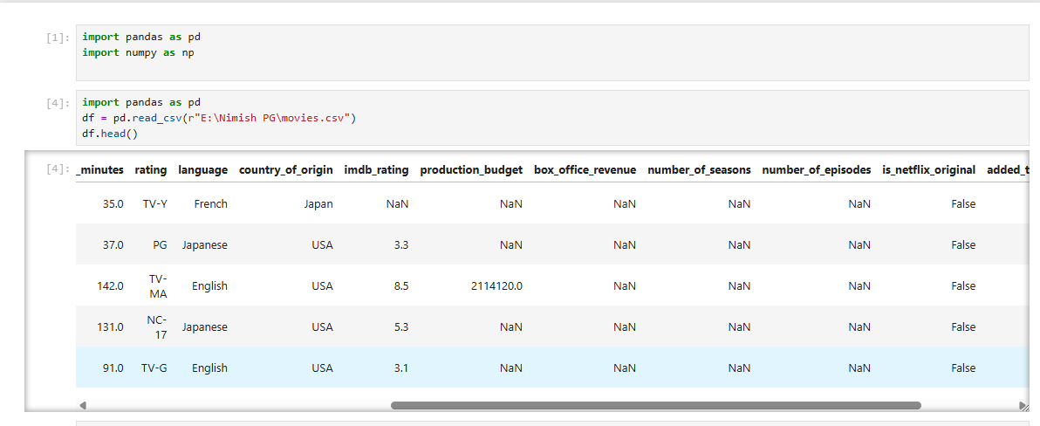
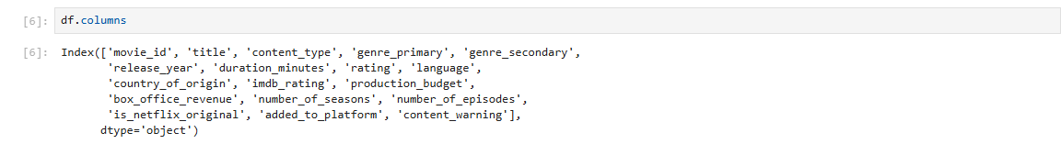
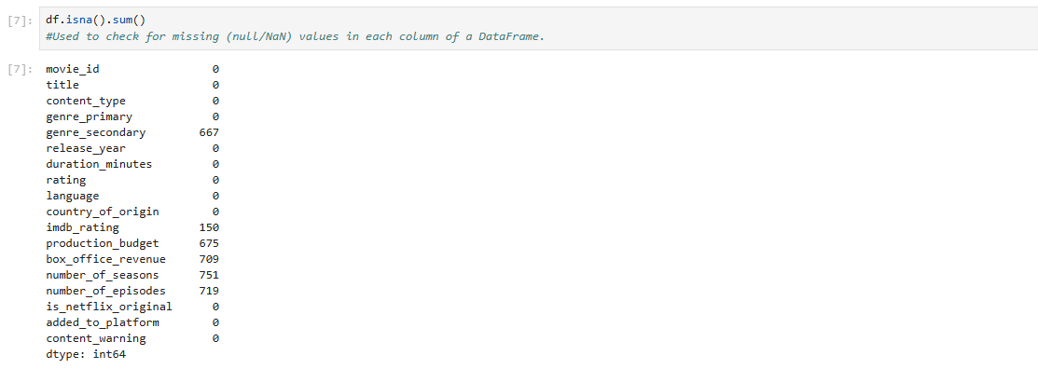
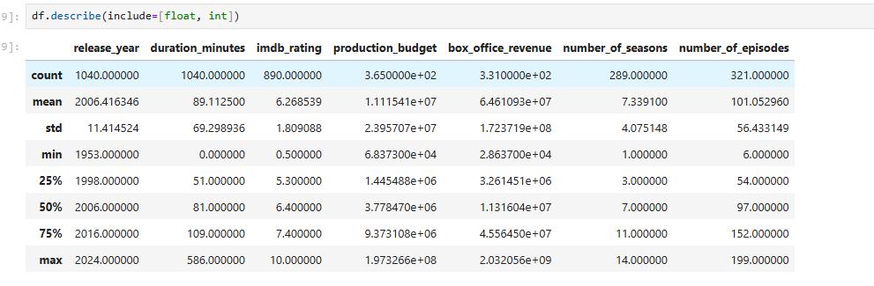
Important observations:
- Total Records: 1040
- Average Duration: 89.11 minutes
- Average IMDb Rating: 6.27
- Earliest Release Year: 1953
- Latest Release Year: 2024
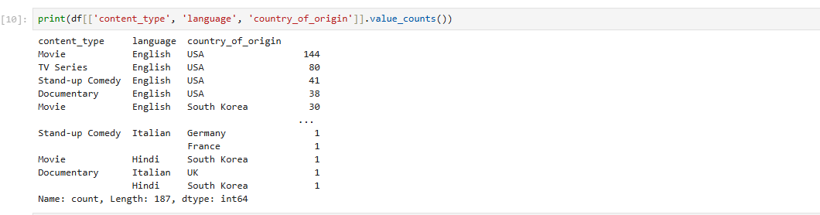

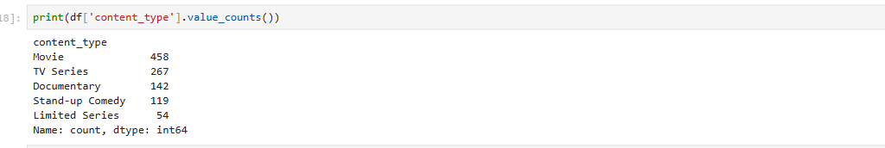
Content Type | Count
Movie | 458
TV Series | 267
Documentary | 142
Stand-up Comedy | 119
Limited Series | 54
Movies represent the largest portion of the dataset.

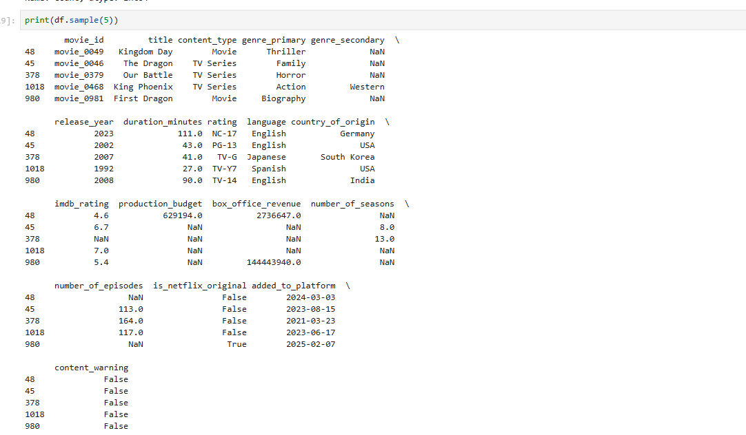
Power BI Dashboard Overview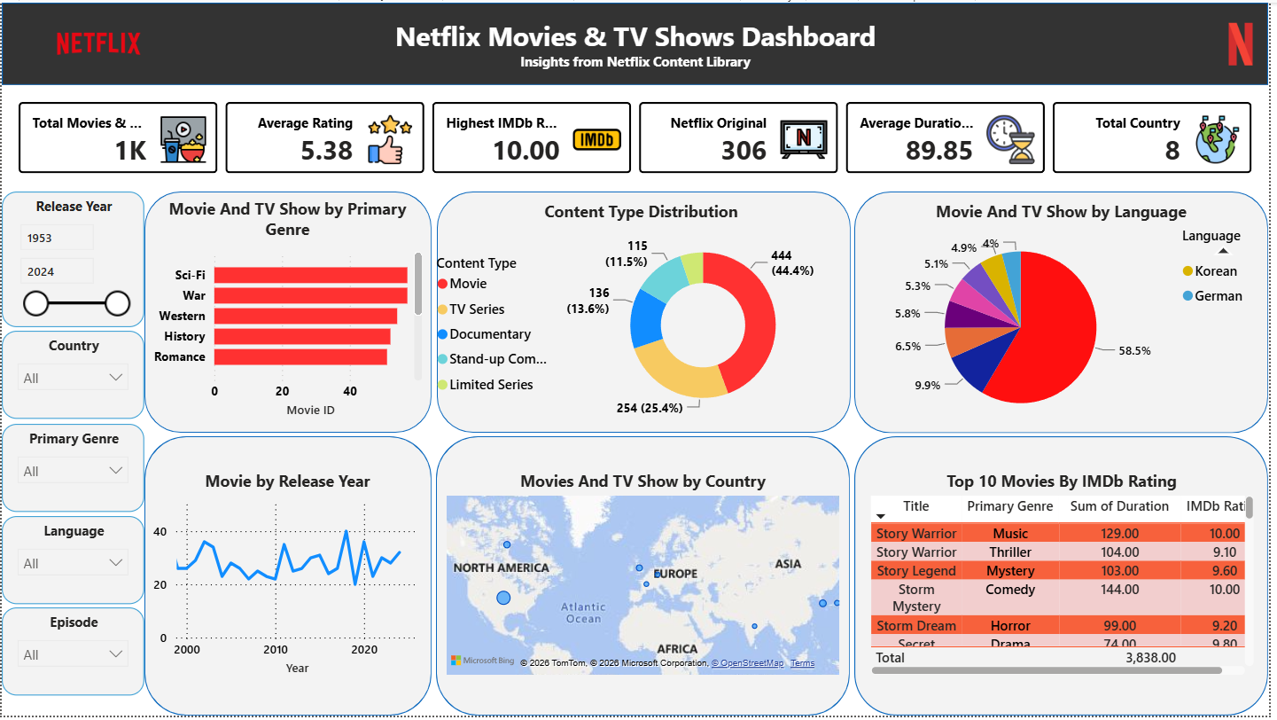

Conclusion
This project demonstrates how Python and Power BI can be combined to analyze streaming platform data effectively. Python was used to clean and prepare the dataset, while Power BI enabled the creation of an interactive dashboard for visual exploration. The analysis revealed that movies dominate Netflix's library, English is the primary language, and most content has been released in the past decade. Interactive filters and visualizations allow users to explore trends by genre, language, country, and release year, making the dashboard a valuable decision-support and analytical tool.

